**Team Members:**

Karim Ahmed Adel Elhosseiny.  
 Mahmoud Reda.  
 Sergi Samir Boules Rizkallha.

**Project overview:**

**-Aklaa Beyti:** our website is mainly used for ordering many different kinds of food meals but the difference here is that the meals that the customer is ordering is 100 percent prepared at home. So your meals are totally healthy, tasty, delicious, and amazing. We have a very well-talented chefs that can prepare different categories of food meals. Our users have the ability to see the chef profile (chef’s name, meals, comments from other users, videos for preparing the meal). They also have the ability to become a chef by uploading their profile and the profile is going to be approved by the admin. There is a great privilege that your user account can be upgraded to VIP membership account. Now the user can unlock any chef whoever his rank and order from him/her any meals the user wants.

1)login page: here the user is asked to put his email and password to login to his account.

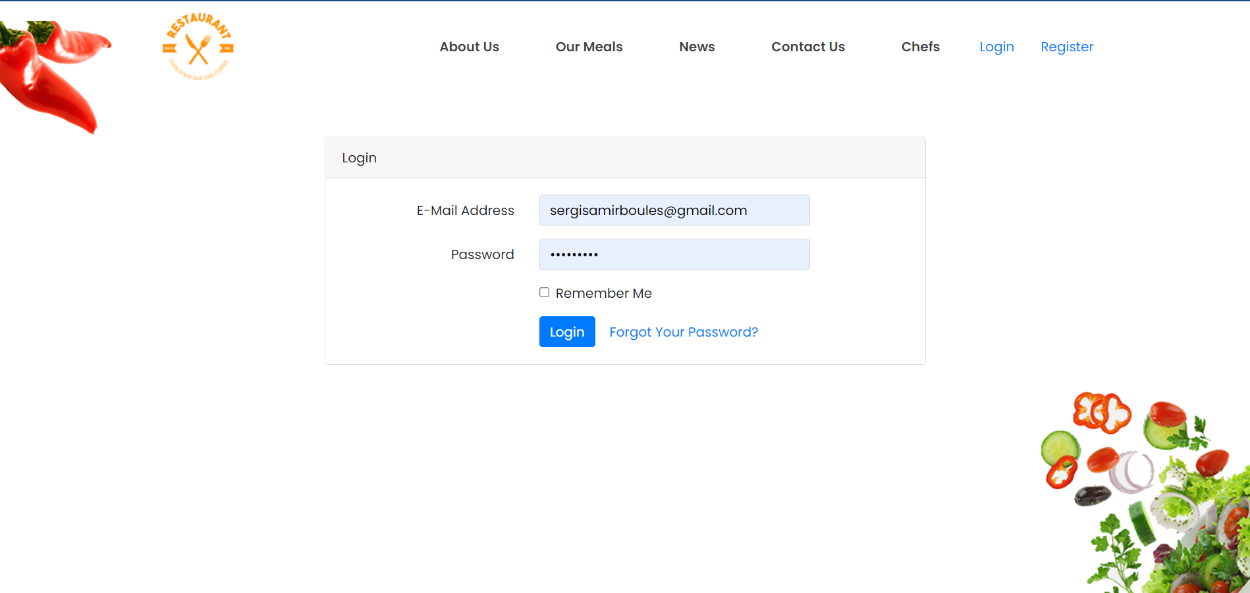

2)home page: here is the home page without signing in or register.

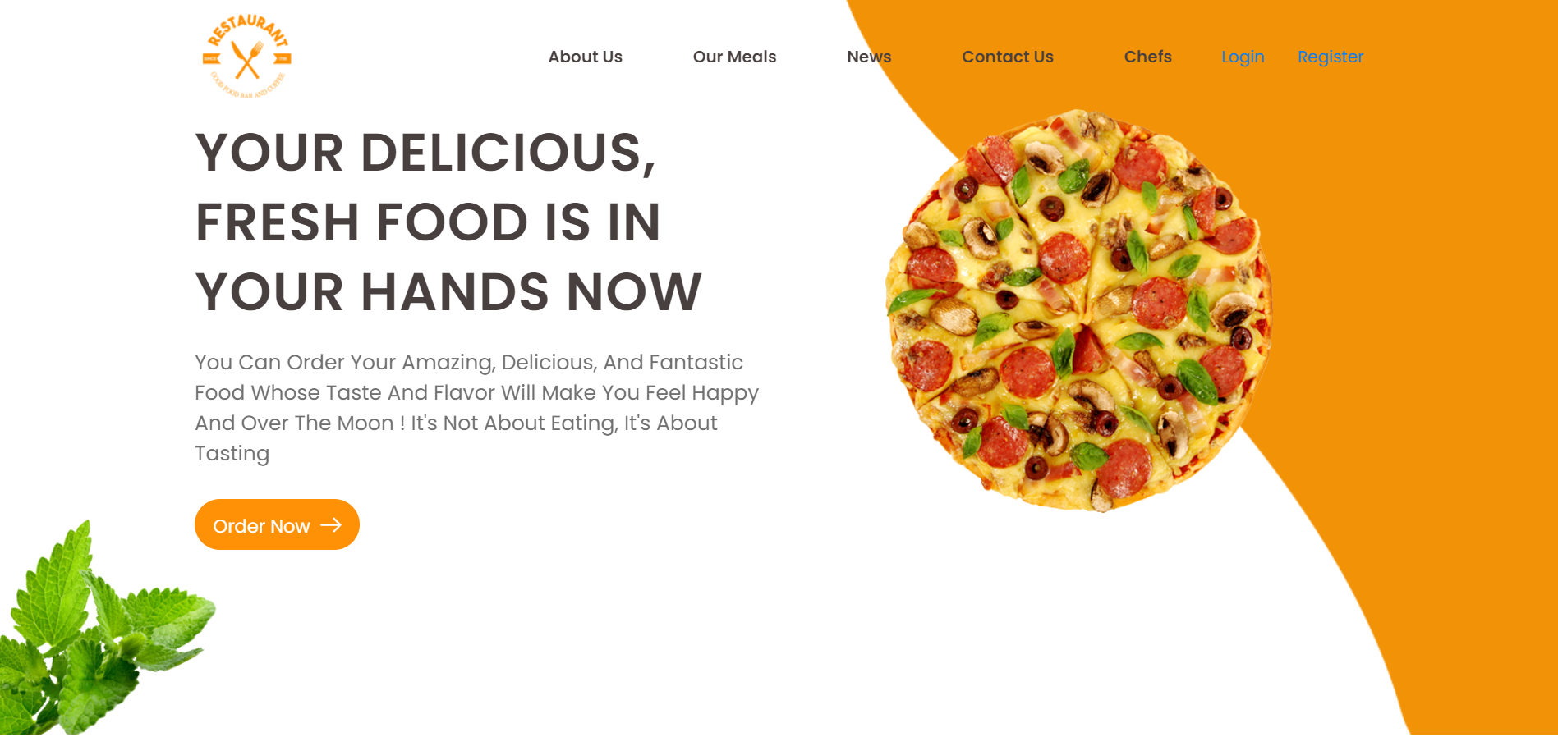

3)home page: here is the home page when user logged in to his/her account.

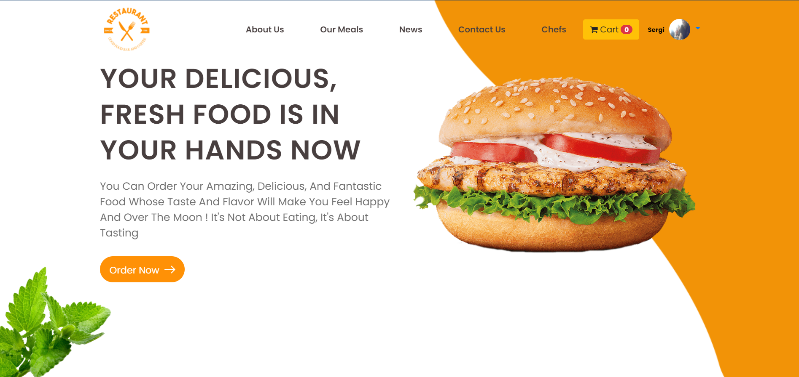

4)register page: here the user has to register his/her information in order to get access on the website.

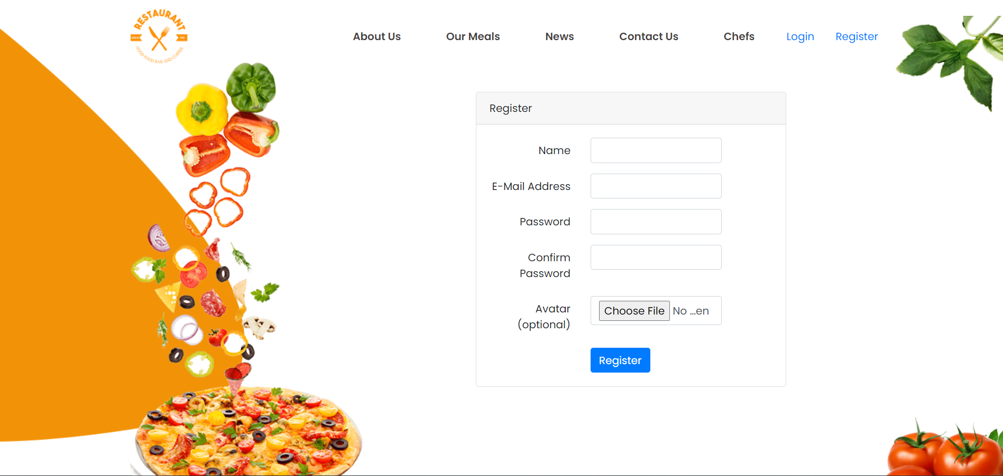

5)meals section from home page: here we have our menu that the user can order whatever he/she wants.

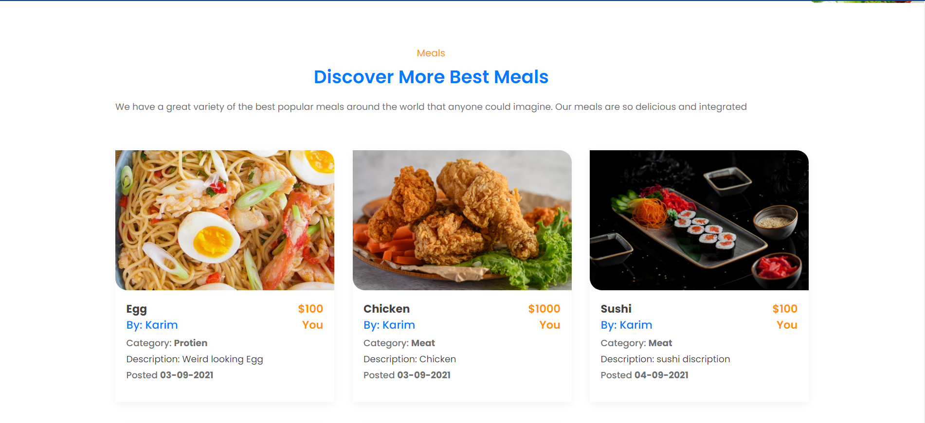

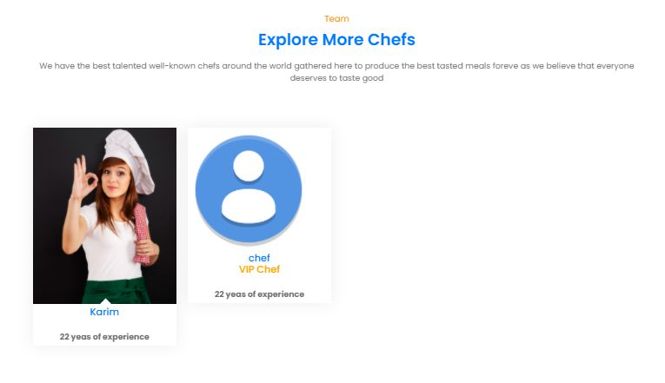6)Chefs section from home page: here we have our best chefs team that are so dedicated to their work to prepare the best taste the customer deserves.

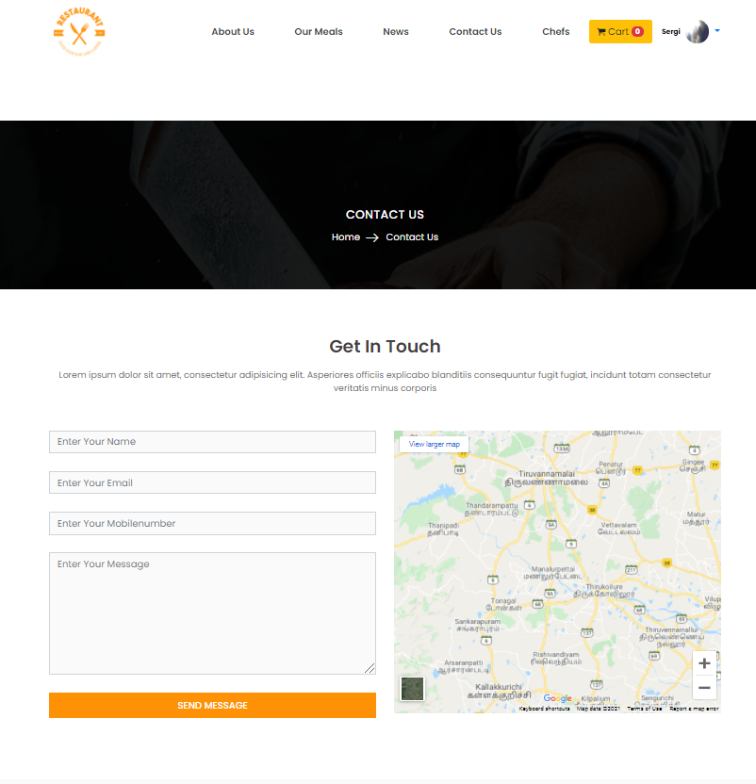7)get in touch section from home page: here users can send their recommendations to the website developers.

8)VIP account page: here the user will purchase a VIP membership account so the user will have extra privileges.

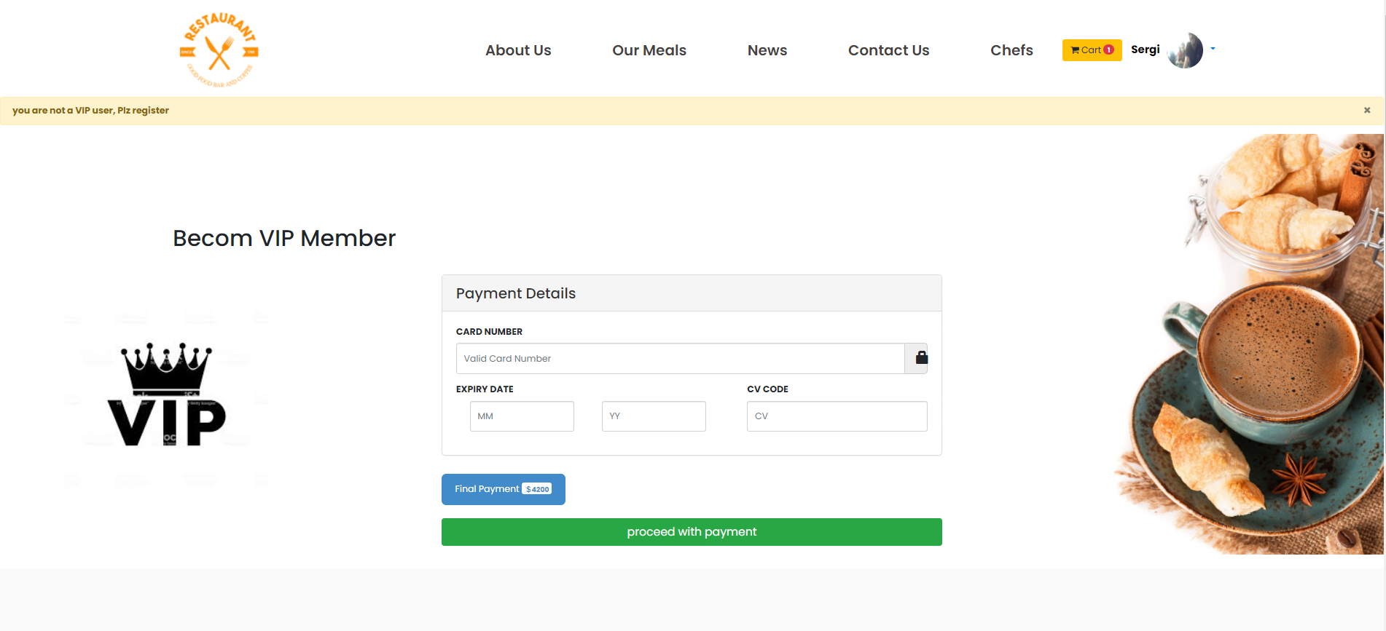

9)cart and purchase operation page: here the meals that the user ordered will appear here with the total price. 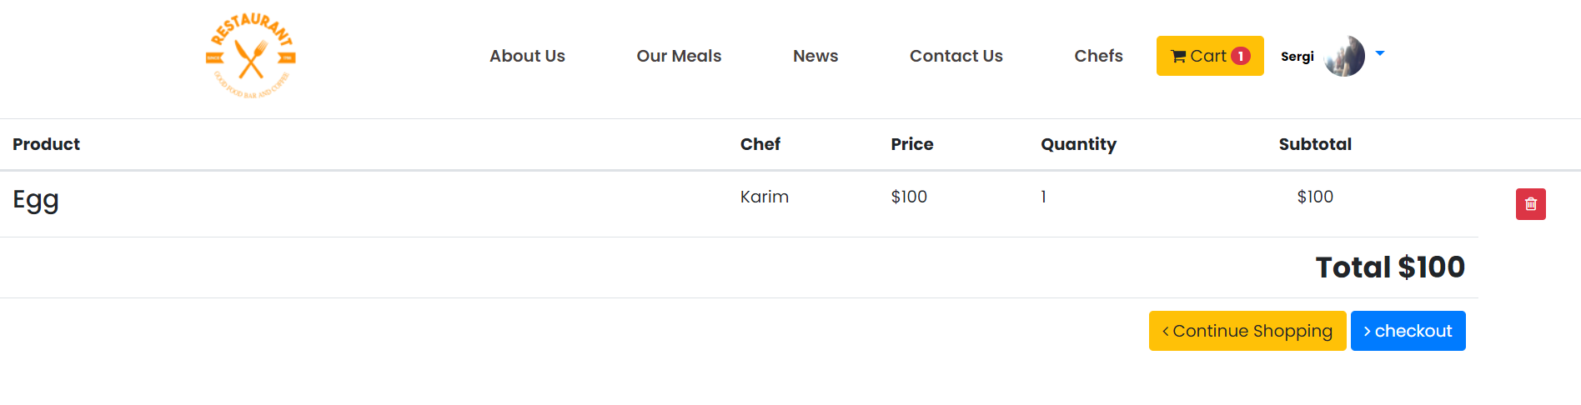

10)Chef form page: here the users can upload their CVs with years of experience.

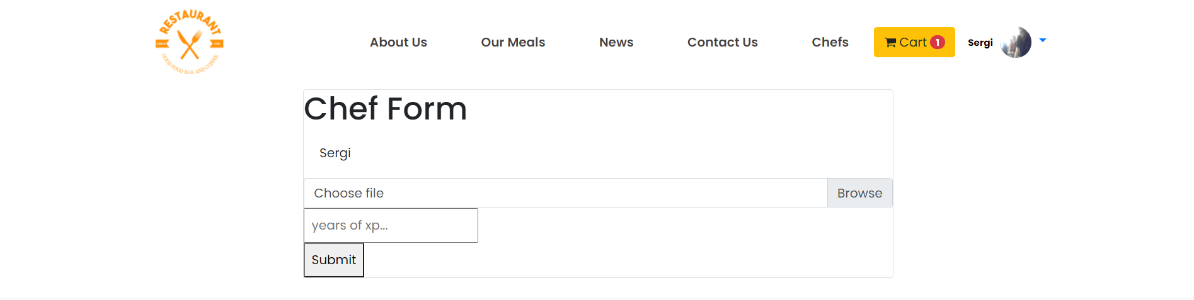

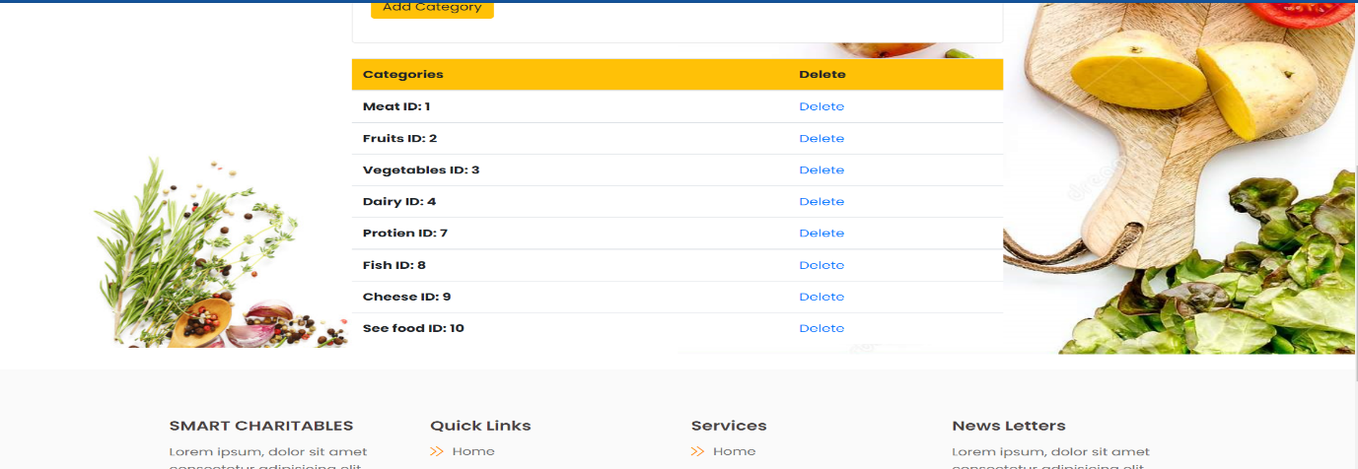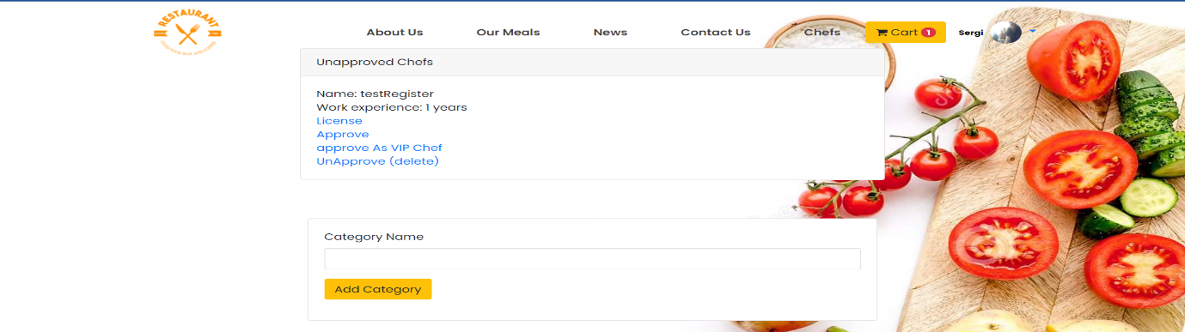11)admin dashboard: here the admin can approve or disapprove the chefs that uploaded their CVs and can add another food category or delete it.

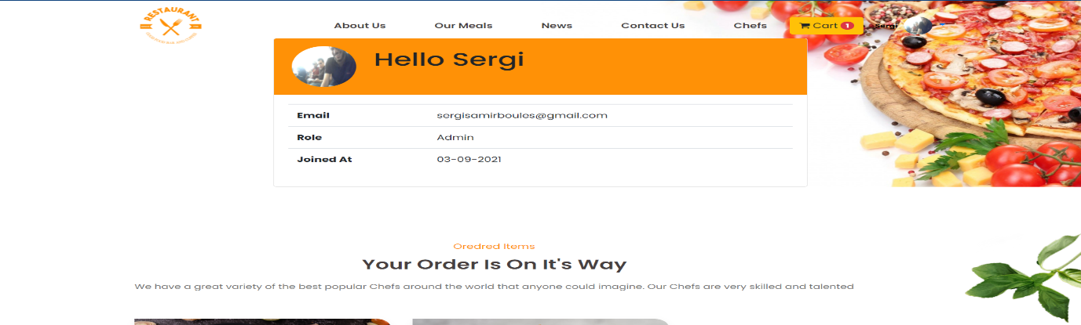12)user dashboard: here the users can see their previous orders meals and their subscriptions to their favorite chefs.

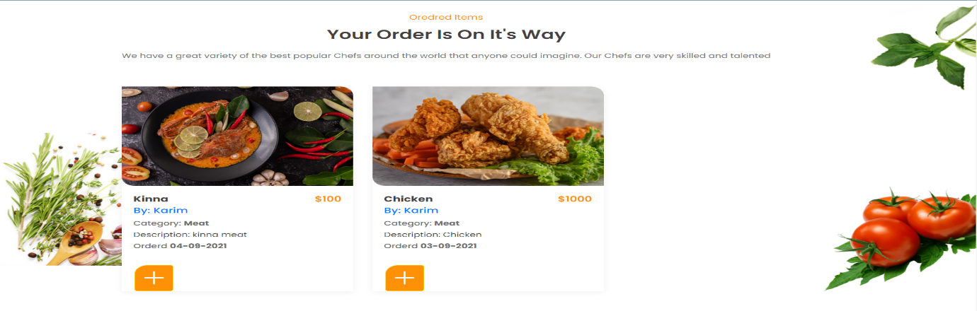

13)chef dashboard: here the chefs can submit new meals with their descriptions and can also delete meals.

